Foodies.com
Design Document

Version 1.0



Group Id: F23023C6CB (BC200401911)

Supervisor Name: Hafiz Bilal Saqib

Revision History
Date (dd/mm/yyyy) | Version | Description | Author
18/01/2024 | 1.0 | "Foodies.com" is a web base application connecting food lovers with restaurants. The core features include easy login and signup options for restaurant owners, food lovers, and administrators. Users can explore a curated list of restaurants, search for specific ones, view detailed menus and locations, and place orders directly through the platform. Real-time chat functionality allows users to communicate with restaurant representatives, fostering a personalized experience. Foodies.com encourages user engagement by enabling them to rate and review restaurants, contributing to a community-driven atmosphere. Restaurant owners have the capability to post enticing offers, with users in the area receiving notifications. The admin plays a crucial role in managing orders, user accounts, and overseeing the overall statistics of Foodies.com through a dedicated dashboard. | BC200401911

Table of Contents

- Introduction of Design Document
- Entity Relationship Diagram (ERD)
- Sequence Diagrams
- Architecture Design Diagram
- Class Diagram
- Database Design
- Interface Design
- Test Cases

- Introduction of Design Document
After software requirement specification (SRS) document completion the next phase in software development process is design document. Design document provides an overview of what and how software developer or development teams will build software. A software design document ensures that the software design specifications are clear and understandable by everyone. It defines what the product is capable of and how to achieve it. Everyone needs to understand what is possible, what is not, and what systems to develop. It also ensure that the product is built to meet the requirements and is consistent with what was agreed prior to product/software release. Software design documentation not only helps others understand the system and provides documentation for future projects, but also gets you thinking about the overall system architecture.
In design Document Includes
- Entity Relationship Diagram (ERD)
- Sequence Diagrams
- Architecture Design Diagram
- Class Diagram
- Database Design
- Interface Design
- Test Cases
Entity Relationship Diagram (ERD)
ERD is a diagram that shows the relationships between a groups of entities stored in a database. In other words, the ER diagram helps to explain the logical structure of a database. ER diagrams consists of Entities, Attributes, and Relationships. ER diagrams have many shapes like: rectangle shape represent entities, ellipses shape define attributes, and diamond shape represent relationships.

Sequence Diagrams
Sequence diagrams is the interactions between objects in a single use case. It shows how different parts of a system interact to perform a function. In other word sequence diagram shows how different parts of a system work in sequence to complete a task.
Architecture Design Diagram
An architecture diagram is a system diagram used to abstract the overall layout of a software system and the relationships, constraints, and boundaries between its components. It is an important tool because it provides an overview of the software system's physical layout and development plan.
Class Diagram
A class diagram describes the characteristics and operations of the classes as well as the constraints placed on the system. A class diagram shows a set of classes, interfaces, connections, interactions, and constraints.
Database Design
Database design includes entity sets and their attributes, and as well as rules or relationships between those entities. A properly designed database is easy to maintain, improves data consistency, and is economical in terms of disk space. Database design decide how the data elements are related and what data should be stored.
Interface Design
The user interface is the look and feel of the application through which users interact to use the software. Users can operate and control the software and hardware through the user interface. The user interface is part of the software and is designed to help users understand the software. Moreover they provides the basic platform for human computer interaction.

Test Cases
A test cases is a document that contains a set of test data, preconditions, expected results, and post conditions designed for a specific test scenario to ensure that specific requirements are met.
Purposes of design Document
Design Documentation is a set of documents and resources covering all aspects of software design. The purposes of Design documentation provide information about users, product features, and project timelines. Moreover the design documents provided the all necessary implementation details to the team and stakeholders. The main goals of design documentation is to keep everyone thinking about one goal and optimize the work of all employees, ultimately leading to high engagement and achieved the goals of product.
Benefits of design document
- Design document provides overview of whole application
- Project documentation is an exercise in identifying the focus of a project.
- Project documentation is important because it tells why we and how a product or project was developed.
- This allows everyone involved to understand what was done and why so the end result can be as good as possible.
- Availability of project documentation also facilitates subsequent revisions and updates.
- Essentially, this helps to make the design process smoother and ensure the success of your project.

- Entity Relationship Diagram (ERD)
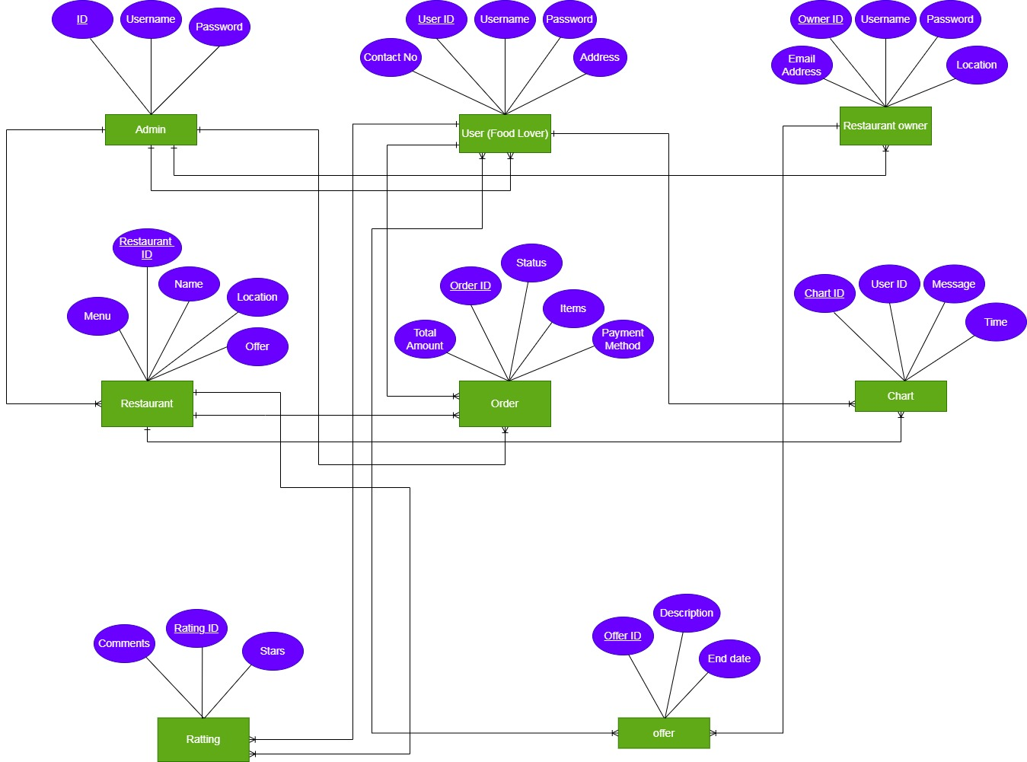
- Sequence Diagram

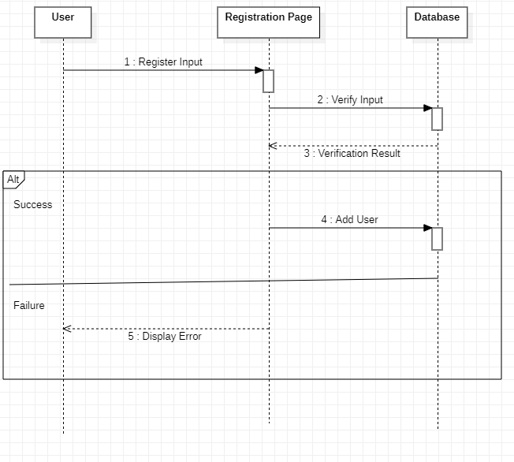

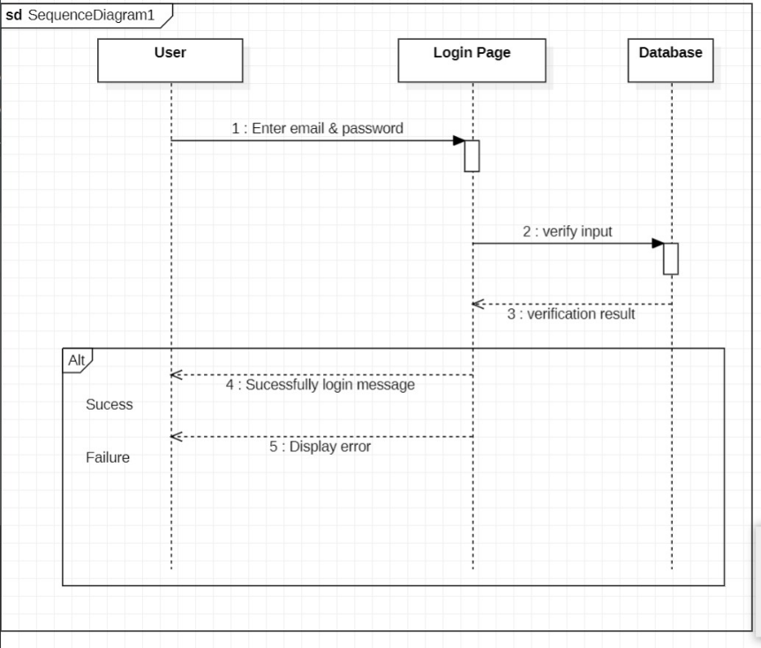

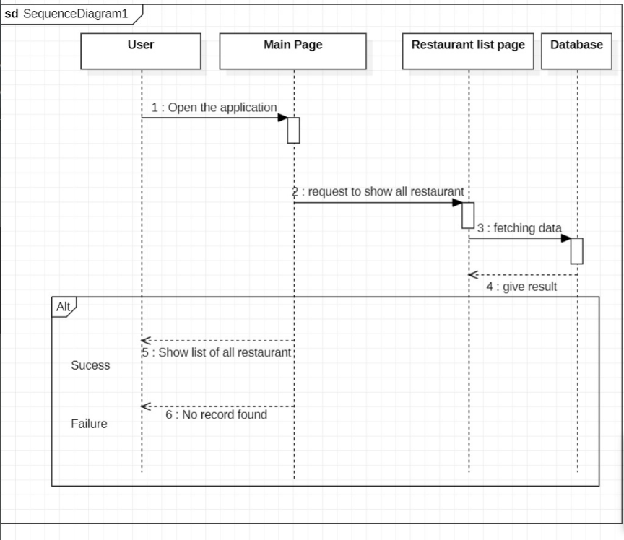

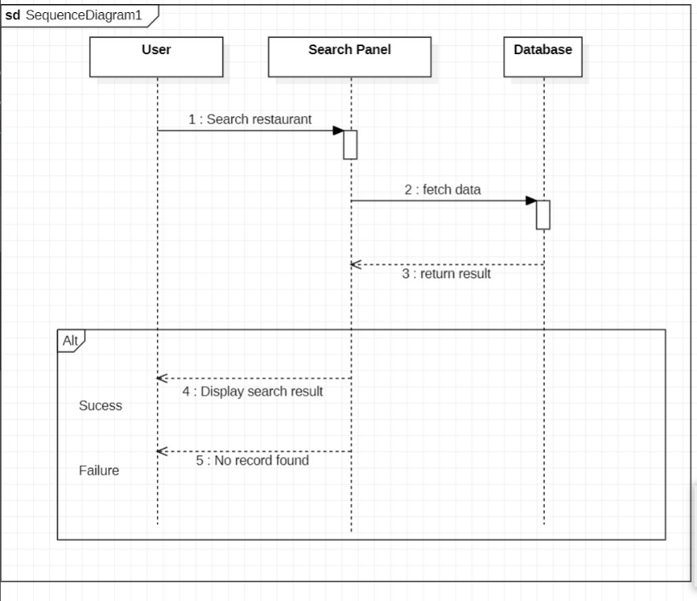

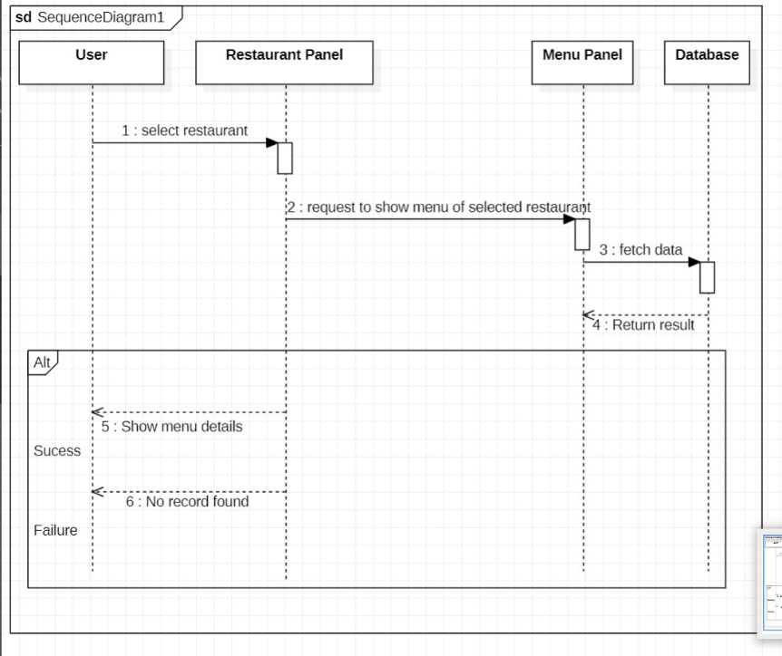

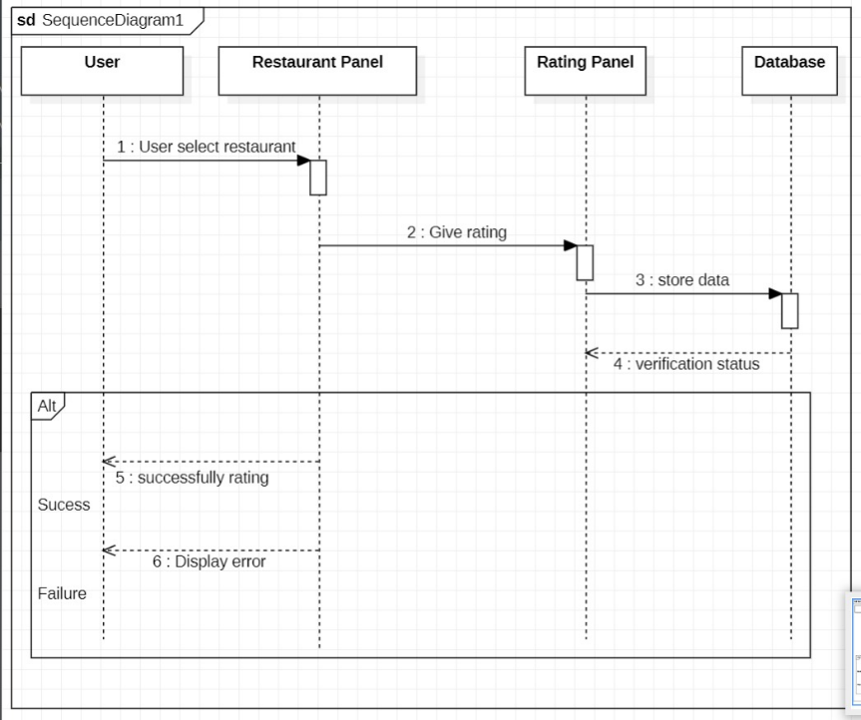

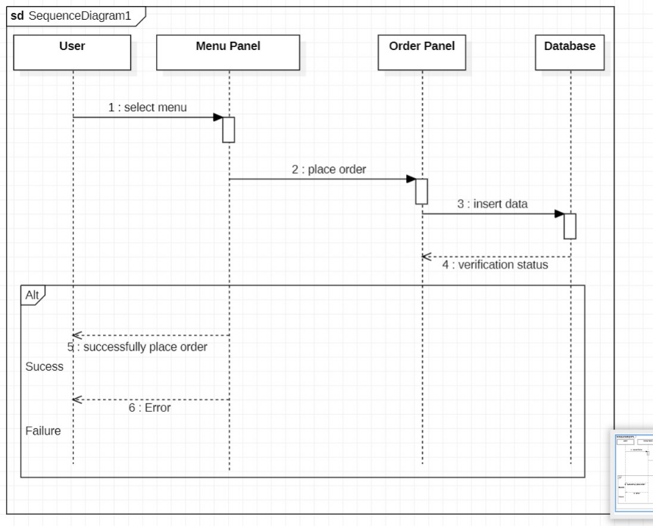

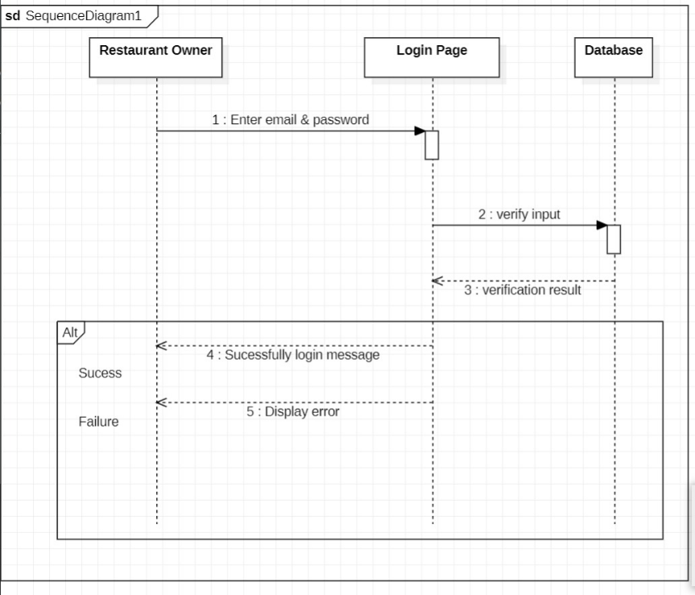

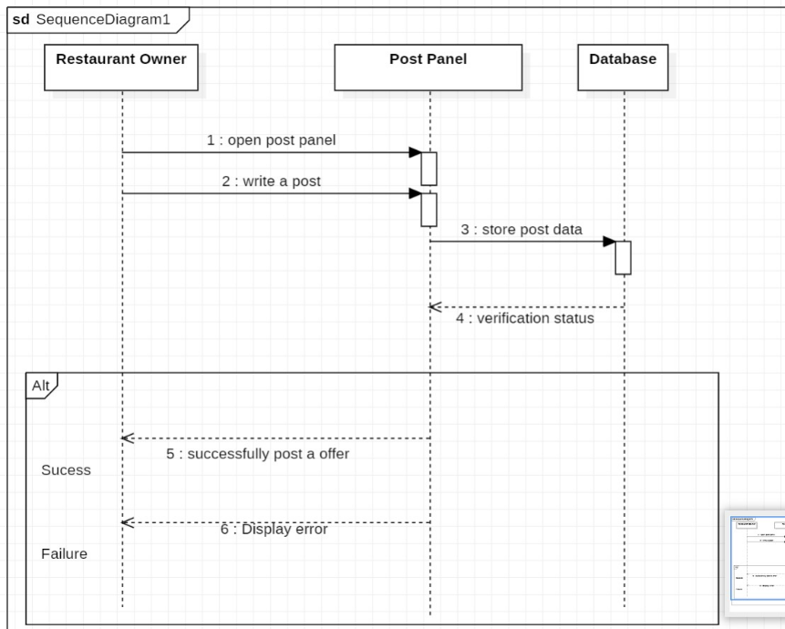

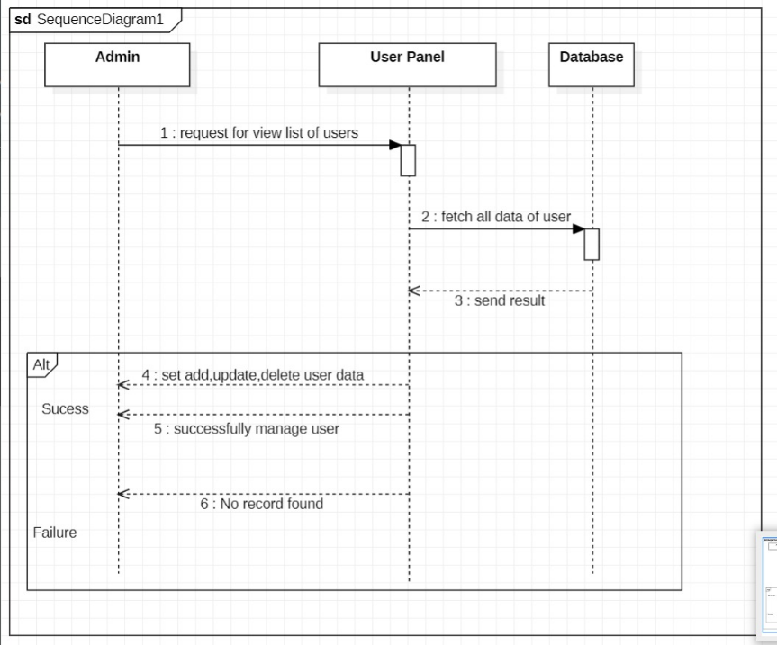

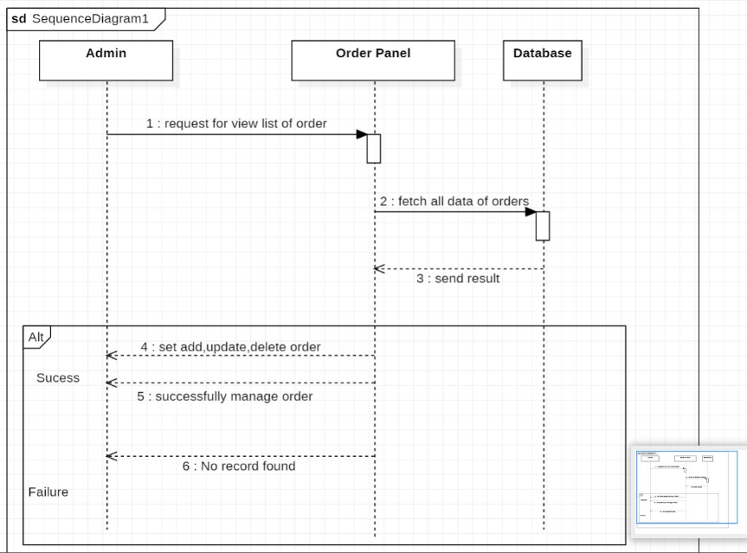

- Architecture Design Diagram
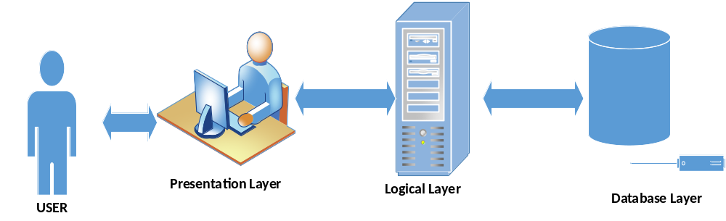
- Class Diagram
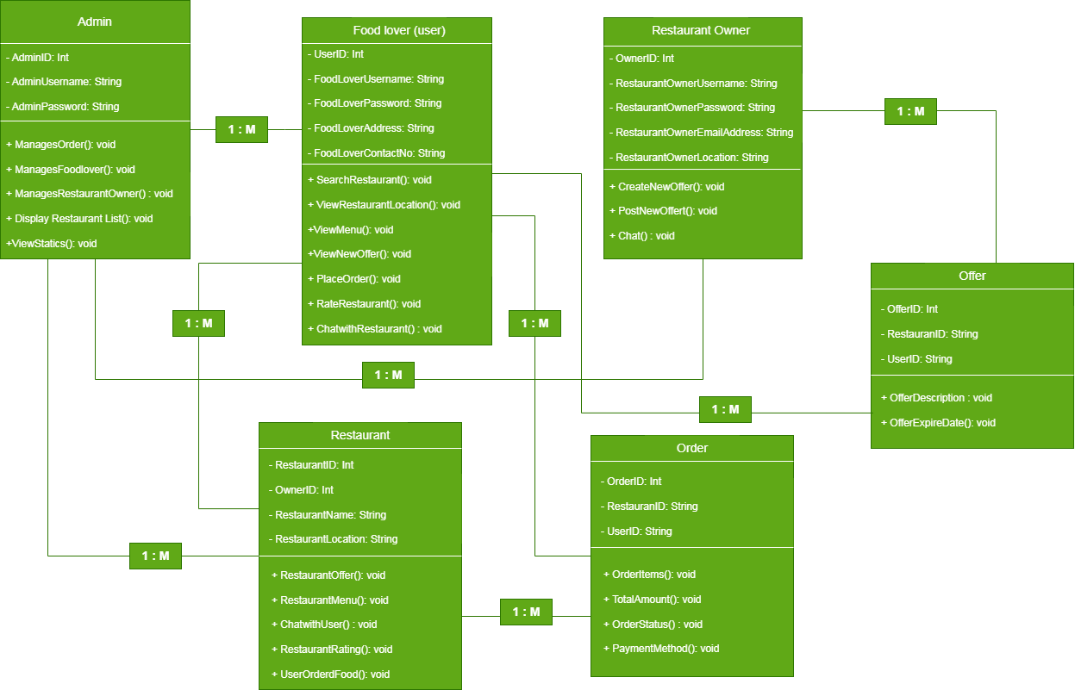

- Database design

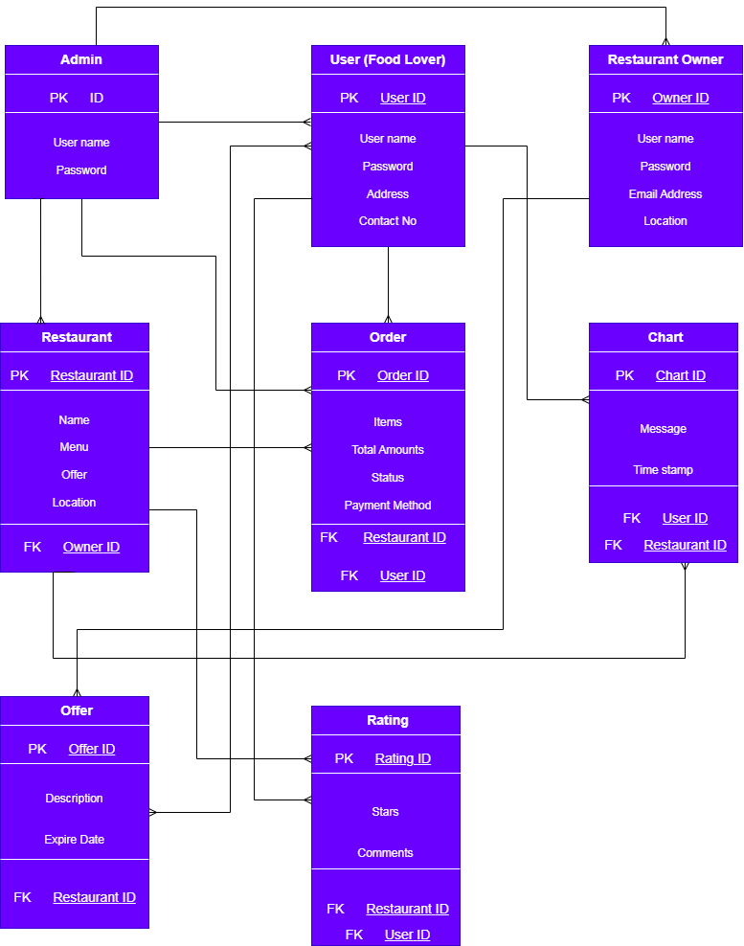

- Interface Design

Main Interface
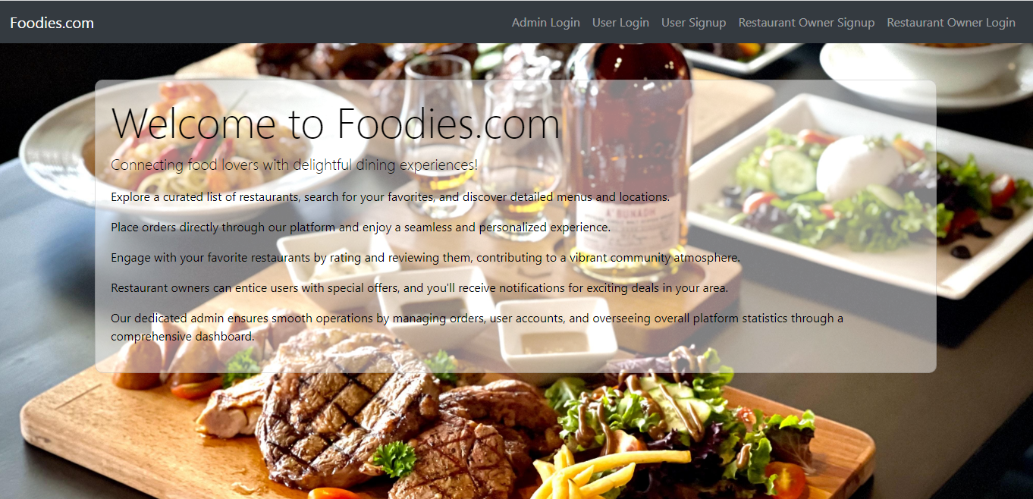

Admin Login

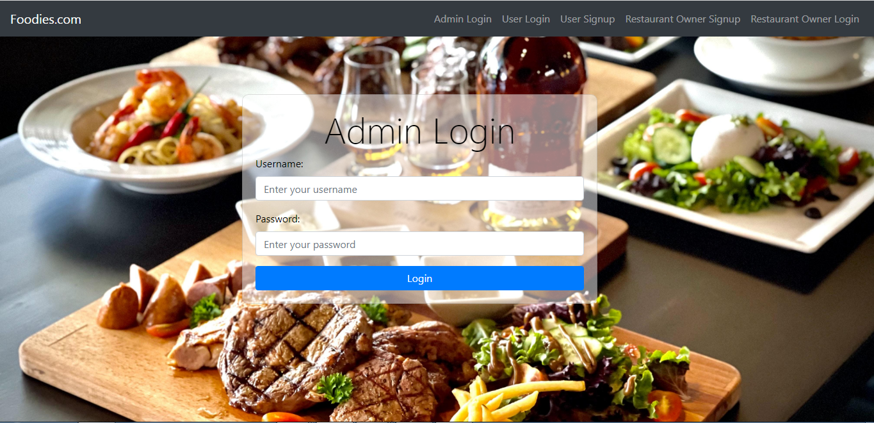

User (Food Lover Signup)
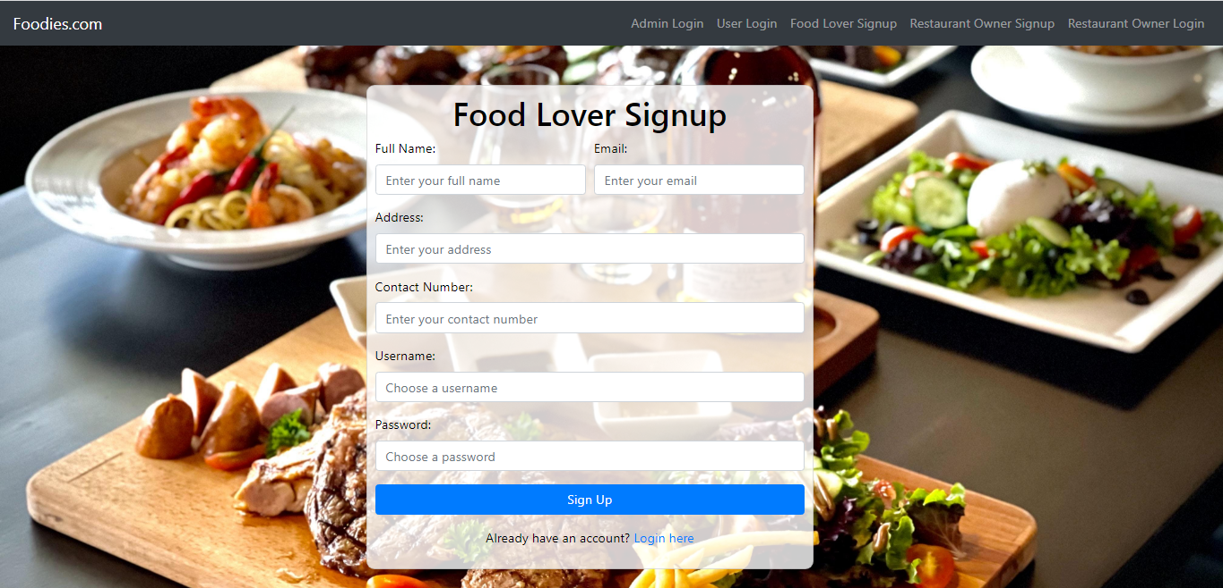

Food Lover Login
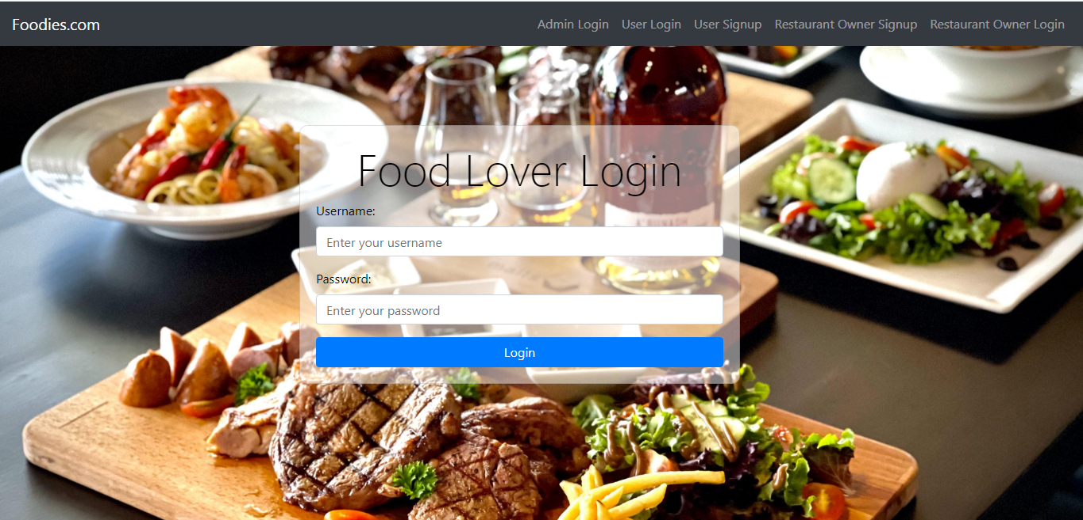

Restaurant owner signup

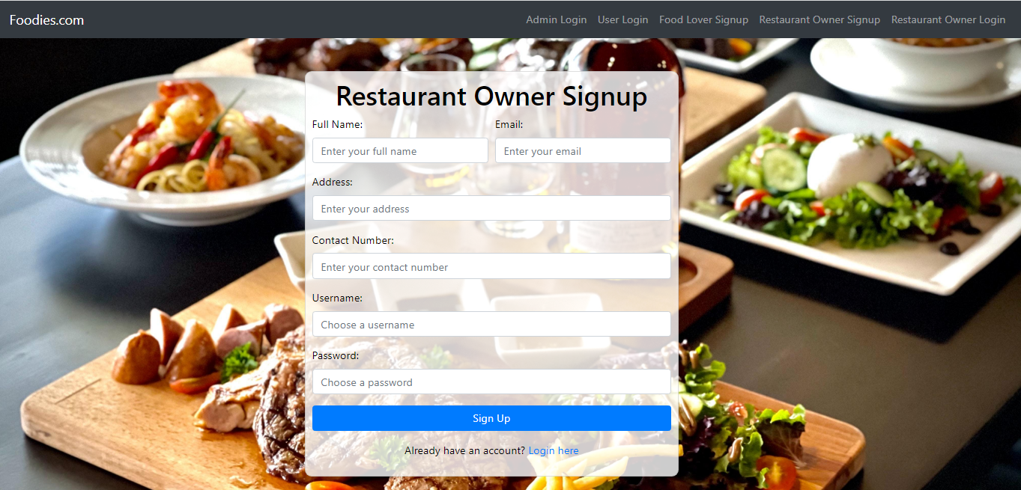

Restaurant owner login

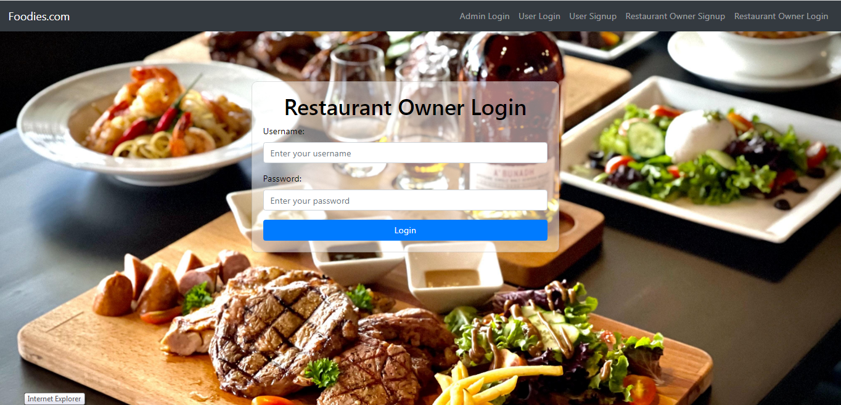

- Test Cases

Test Case ID | Test Case Title | Input | Test Case Output | Result | Tested By
TC001 | Verify Admin can login with valid credentials | Valid username and password | Successful login | Pass | BC200401911
TC002 | Verify Admin cannot login with invalid credentials | Invalid username and password | Unsuccessful login | Pass | BC200401911
TC003 | Verify Admin can manages orders with valid details | Create Order Update Order Delete Order | Successfully Manages (Create, Update and Delete) | Pass | BC200401911
TC004 | Verify Admin cannot manages orders with invalid details | Invalid order details or no order found | Order Cannot manages or no order has been place yet | Pass | BC200401911
TC005 | Verify Admin can manages the users with valid details | User name, Password, address contact and location | Successfully manages (add, update, delete) | Pass | BC200401911
TC006 | Verify Admin cannot manages the users with invalid details | Invalid username, password, address, location etc. | Unsuccessful | Pass | BC200401911
TC007 | Verify Admin can add restaurant list | Restaurant name  Location | Successfully added | Pass | BC200401911
TC008 | Verify Admin can display restaurant list | Restaurant name  Location | Successfully display | Pass | BC200401911
TC009 | Verify Admin can add restaurant details | Menu  location | Successfully added | Pass | BC200401911
TC010 | Verify Admin cannot manages the users with invalid details | Invalid users details | Unsuccessful cannot manages or users cannot found | Pass | BC200401911
TC011 | Verify Admin can view statics | Register users, order details etc. | Successfully view | Pass | BC200401911
TC012 | Verify Restaurant owner can login with valid credentials | Valid username and password | Successfully login | Pass | BC200401911
TC013 | Verify Restaurant owner cannot login with invalid credentials | Invalid username and password | Unsuccessful login | Pass | BC200401911
TC014 | Verify Restaurant owner can post new offer | Offer details and expire date | Offer successfully post | Pass | BC200401911
TC015 | Verify Restaurant owner cannot post new offer | Invalid details | Unsuccessful | Pass | BC200401911
TC016 | Verify User(Food lover) can login with valid credentials | Valid username and password | Successfully Login | Pass | BC200401911
TC017 | Verify User(Food lover) cannot login with invalid credentials | Invalid username and password | Unsuccessful login | Pass | BC200401911
TC018 | Verify user can search particular restaurant | Restaurant name and location | Restaurant details | Pass | BC200401911
TC019 | Verify user can view offer | Search restaurant and location | View Offers |  | BC200401911
TC020 | Verify user can view menu details | Restaurant name and location | View Menu | Pass | BC200401911
TC021 | Verify user can place order | Food items, total quantity, total amount and payment method | Order successfully place | Pass | BC200401911
TC022 | Verify user cannot place order | Invalid inputs and quantity | Unsuccessful while order placing | Pass | BC200401911
TC023 | Verify user can view order status | Order id and details | Pending or process | Pass | BC200401911
TC024 | Verify user can real time chat with restaurant representor | Message details and queries | Successfully real time chatting | Pass | BC200401911
TC025 | Verify user can give rating to particular restaurant | Rating stars and message | Successfully rated | Pass | BC200401911

